UNIT 1 : A VISIT FROM A PEN PAL
PERIOD 4 : LISTEN
A/ Task 1:
- Listen to the conversation between Ba and Yoko from the previous lesson
- Now listen again and choose the correct answer ( you have 5s for each question below)
- Who’s Yoko talking to ?
- She’s talking to Ba, one of Lan’s colleague.
- She’s talking to Ba, one of Lan’s classmate
- She’s talking to Ba, one of Nga’s pen pal.
- What does Yoko think about people in Viet Nam ?
- The Vietnamese are welcoming and helpful.
- The Vietnamese are inattentive and helpful.
- The Vietnamese are funny.
- What can you hear from the conversation ?
- Lan has never been to Japan before.
- They will take the bus home after school.
- The two cities are not totally alike.
Answer: 1. ________ 2. __________ 3. _________
B/ Task 2
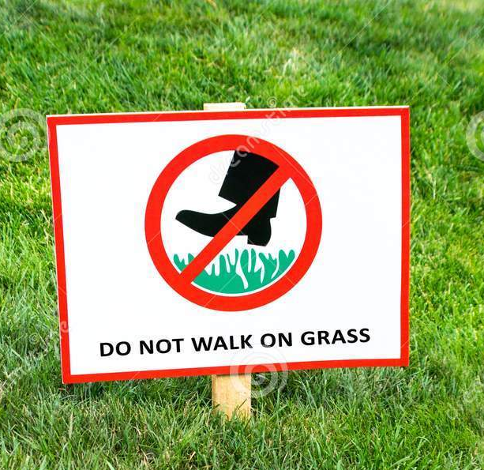
Look at the pictures. What are they trying to advise you ?
1. The sign says:
A. It’s prohibited to step on the grass
B. You must look at the grass.
C. You must wear shoes when walking on the grass
D. It’s admirable to water the grass.



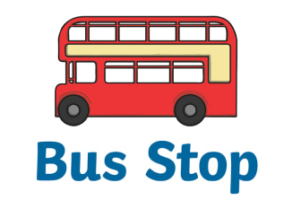
2. It’s advisable to travel around the city by ____________ to keep the air clean.

3. Where would you like to wine and dine your pen pal at the first meeting? Why?


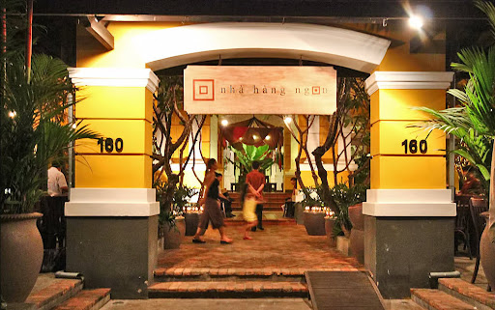

A. a brasserie B. a fancy American restaurant C. an authentic Vietnamese restaurant
C/ Task 3
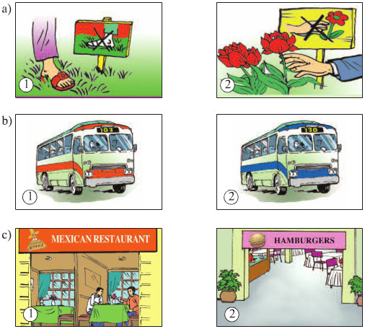
Part 1: Tim Jone’s Mexican pel pal, Carlo, is visiting the USA. Listen to their conversation and check (✓) the number of the correct pictures.

Answer: a. ______ b. ______ c. ________
VOCABULARY ( ghi vào tập)
1. Downtown (adv) /ˌdaʊnˈtaʊn/: in or to the central part of a city:
E.g: Let’s go to the bookstore downtown.
2. To catch a bus / a taxi
- Caught /kɔːt/ (Verb in past simple)
E.g: We should get up early to catch the bus to school.
3. Park keeper (n) /pɑː(r)k ˈkiːpə(r)/: someone who looks after the public park.
E.g: I saw a park keeper growing new trees yesterday morning.
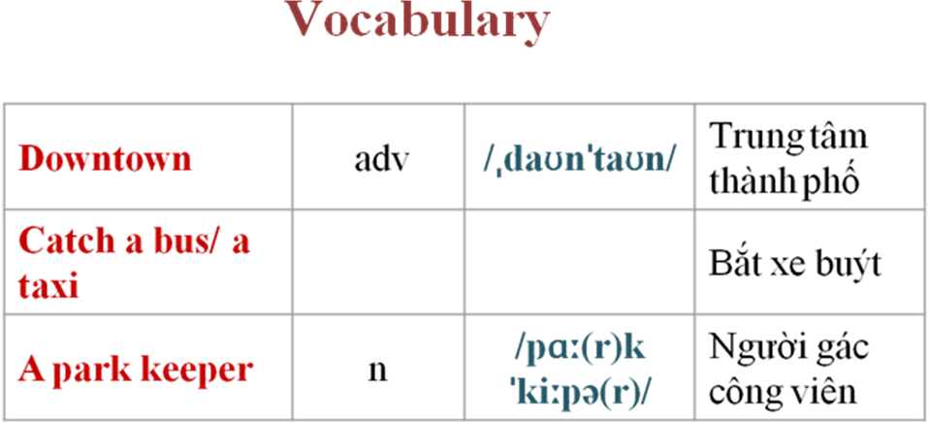
GRAMMAR STRUCTURE FOCUS: ( ghi vào tập)
It’s time + subject + past verb form

E.g: It’s time we c a ___ g ___ ___ a bus home.
S + would rather (+ not) + V (bare) + than + V (bare)
* ‘d rather = Would rather
E.g: Billy would rather watch TV than read a book.
(This means Billy likes watching TV more than reading a book.)
PRACTICE: ( ghi vào tập)
- Rewrite the sentences that have the same meaning. Use “would rather”.
- I don’t want to buy apples. I prefer oranges.
- I would rather buy ___________________________________
- I like staying home to watch Netflix more than going out amid the pandemic.
- I’d rather ____________________________________________
- Kate prefers paying by credit card all the time.
- Kate’d much _________________________________ .
- Yoko would prefer to walk.
- Yoko _________________________________
5. Her children would rather go camping than go swimming in the summer
- Her children prefer _________________________________
- Listen to the conversation again . Fill in the blank to complete the summary. ( ghi vào tập)
Carlo was hungry so he and Tim decided to go to the (1)_____________ _______________. To catch the bus, they had to go through the park on (2)________ _________. Carlo didn’t notice the sign as he was walking on the grass which made Tim pretty worried. Plenty of new grass was being grown by the park (3) _____________. After a while, they (4)_________ a ________ bus to move on. Since Carlo preferred American food to (5) ______________ food, they headed for a proper place to eat (6)______________.
D/ Task 4
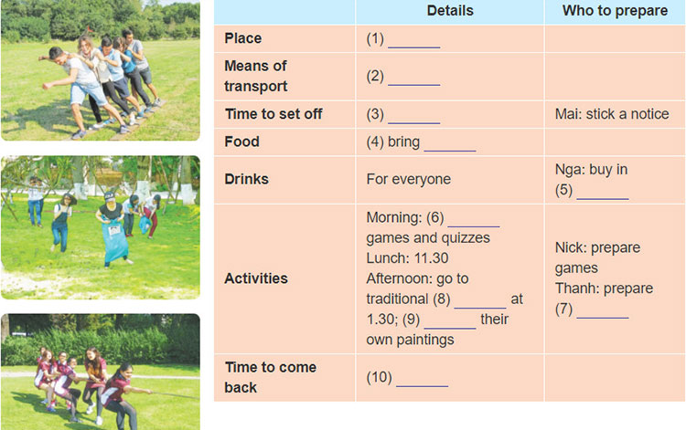
Part 1: Listen to the tape then fill in the blank with no more than 3 words to complete their plan.

1. ___________ 2. ____________ 3. _____________ 4. _______________ 5.____________
6. ___________ 7. ____________ 8. _____________ 9. ______________ 10. _____________

Part 2: Read the plan again and mark the sentences True or False:
1. Everyone is going to turn up at Green Park at 8 a.m.
2. Nga will buy food and drinks for all members.
3. Their class will visit traditional ceramic village after lunch.
4. They are returning home at 5 p.m
Homework:
1. Learn new words by heart.
- Review two grammar structures.
- Write a short paragraph to tell what you would like to do after the covid outbreak (from 80- 100 words)
*You can write down ideas or record your speech.

